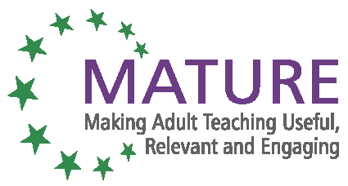

MATURE Unit 4 Social inclusion annex 2

Ex/Inclusion

How:
Each participant has a sheet of paper with the definition of “Social Inclusion” published by the EU or another European body. The facilitator emphasizes the fact that this course is about older people’s inclusion (55+) and hard-to-reach people. Given this information, is the definition sufficient, what is missing, what is wrong, what should be phrased differently?
(Work in groups or pairs, let them share their contributions in the plenary session afterwards).
As facilitator, if the topics of health, dependency, culture, and attitude are not particularly stressed, point them out as a question: are they relevant, should they be part of a definition?

Why:
To create the same point of departure for discussion. To introduce the key themes of health, dependency etc.

Next step:
Distributing definitions from the MATURE glossary and data to support definitions.

Why:
To raise awareness and have a common basis of knowledge.


With the support of the Lifelong Learning Programme of the European Union.
This project has been funded with support from the European Commission. This publication reflects the views only of the author, and the Commission cannot be held responsible for any use which may be made of the information contained therein.

