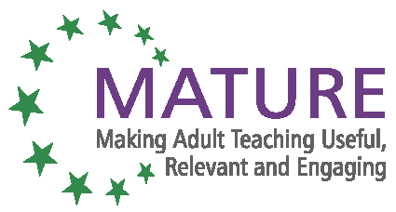

MATURE Unit 4: Social Inclusion annex 3

Methods of resolution

Groups of 3-4 persons, questions on a sheet of paper, space for answers

How:
Divide the group in 3, tell them that they will work on resolutions for including “excluded” people in the group.

1st group: discuss one possible resolution
Open a meta- dialogue about the problem within the group
- How to start, how to configure such a dialogue?
- Reasons to do it this way?
- Reasons not to do it, dangers?

2nd group: discuss one possible resolution
Change the role to include the person(s)
- How can you as a teacher change the role, what kind of roles are possible? The aim is to get acceptance / appreciation by members of the group without overburdening them or the person you have in mind.
- Reasons to do it this way?
- Reasons not to do it, dangers?

3rd group: discuss one possible resolution
Solve the situation by using the approach according to Mezirow:
You as a teacher show the following more /less:
- Presence
- Distance
- Empathy
- Feeling
- Intuition
- Reflexion
- Observation
- Action

Possible additions:
Give out a short paper of Mezirow’s theories
Talk about good examples
Case study
Role play

Why:
This exercise is likely to show participants that there are ways towards a resolution, that there are different ways and that they as a teacher have to decide which way is suitable for the group and the situation.


With the support of the Lifelong Learning Programme of the European Union.
This project has been funded with support from the European Commission. This publication reflects the views only of the author, and the Commission cannot be held responsible for any use which may be made of the information contained therein.

