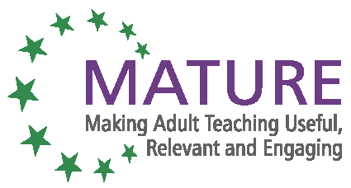

MATURE Unit 9 Towards Self- Organisation annex 2

Introductory Exercise

Why:
In order to understand how self-organisation differs from traditional forms of teaching, this exercise gives hands-on experience.

How:
All participants sit at their tables or in a circle.
Ask them to stand up und turn around once and then sit down again. Probably, all of them will do it even though they might look puzzled.
After they sit down again, explain that this is how teaching is often done; there is an instruction and no additional explanation is given or no choices are offered. The exercise was done to show them how this feels.
After this explanation, repeat the exercise, this time altering it slightly (“turn around the other way!”).
Now you can show them that these two exercises represented the first 2 steps “towards self- orientation”.
The group can discuss this exercise at their liberty.

Follow this with the explanation of the chart “Steps towards self-organisation” (see annex 3).

With the support of the Lifelong Learning Programme of the European Union.This project has been funded with support from the European Commission. This publication reflects the views only of the author, and the Commission cannot be held responsible for any use which may be made of the information contained therein.

