Discover Learning in Later Life in Europe

Anna Grabowska
PRO-MED sp. z o.o., Gdańsk, Poland
anka.grabowska@gmail.com

Abstract— Since more than 10 years learning activities for adult learners are supported by European Union and European Commission. It should be underlined that Lifelong Learning is the basic key concept of EU and EC. They both support access and participation in Lifelong Learning for All. In order to cope with Europe’s ageing population problem in 2000 the Grundtvig Programme was launched. Grundtvig aims to provide adults with ways to improve their knowledge and skills, keeping them mentally fit and potentially more employable. One of the specific aims of Grundtvig is to ensure that people on the margins of society have access to adult education, especially older people and those who left education without basic qualifications. At least 55% of the total funding for Grundtvig goes towards mobility and partnership activities. In the article the chosen Grundtvig projects are presented (LLLab, LISTEN, LLLE, ForAge).
- Grundtvig Partnership LLLab (2009-2011) – Kick off Meeting in Bolu, Turkey

Lifelong Learning – what is it all about [6]
“Lifelong learning means all learning activities undertaken throughout life with the aim of improving knowledge, skills and competences within a personal, civic, social and/or employment-related perspective”.
This definition of Lifelong Learning (LLL) is from the 2001 Communication of the European Commission. In this document the Commission states that all learning opportunities and strategies should be equally applicable to older people, and that senior citizens, including older workers, should have opportunities to participate more actively in society and in the labour market. This includes the role they can play in intergenerational learning. One of the main messages was that traditional educational systems must be transformed to become much more open and flexible, so that learners can follow individual learning pathways, suitable to their needs and interests, and thus genuinely take advantage of opportunities throughout their lives.
In the 10 years since this report, the European Commission has produced several communications and papers highlighting the importance of finding solutions to demographic change in Europe.
Thus, the Commission refers to the need to ensure a balance between the generations in the sharing of time throughout life, in the distribution of the benefits of growth, and in funding demands stemming from pensions and health-related expenditure. Policy and society should find new bridges between the stages of life as an increasing number of "young retirees" seek to participate in social and economic life. Time spent in education is increasing and young working people want to spend time with their children. These changes alter the frontiers and the bridges between activity and inactivity. The Commission has also highlighted the importance of adult learning as a key component of lifelong learning. In 2009, EU Member States and the European Commission strengthened co-operation in education and training with a strategic framework, a follow-up to the earlier Education and Training 2010 work programme launched in 2001. There is recognition that high-quality pre-primary, primary, secondary, higher and vocational education and training are fundamental to Europe's success. However, in a rapidly changing world, lifelong learning needs to be a priority – it is the key to employment and economic success, allowing people to participate fully in society.
The Europe 2020 Strategy will be a successor to the Lisbon Strategy which has not achieved its ambitious goals. The new document for the horizon of 2020 is focused on a social market economy.
There are three important strands:
- economic sustainability,
- social sustainability,
- environmental sustainability.
None of these will be readily achieved unless all countries and their representatives take into account the growing demographic gap, the increase in older people remaining in employment and the desire for retired older people want to live actively in society.

LifeLong Learning for Active Citizenship and Capacity Building – LLLab [5], [6], [7], [8], [9]
The project aims to develop a culture of learning by promoting access to LLL, by increasing participation in adult education and by obtaining a rise in skill levels, better employability, social inclusion, active citizenship and personal development in the European population.
The project partners were following: Project coordinator: Bolu Valiliği – Turkey (Co-ordinator), PRO-MED sp. z o.o. – Poland, Avalon, Iniciatives per a les associacions – Spain, Karpatská nadácia Slovensko- Carpathian Foundation – Slovakia, Inova Consultancy ltd/WiTEC - United Kingdom.
In order to achieve these purposes, project consortium organized activities which on the one hand broadened access to LLL opportunities for older learners and on the other, supported mobility of adults. Project activities, which mainly centered on training and education in different forms, involved young and old people, with different socio-economic levels and backgrounds regardless of gender, ethnicity racial or ethnic origin, religion or belief, disability or sexual orientation: the heterogeneous teams were an enriching occasion to strengthen intergenerational co-operation. Furthermore, each partner dealt with a diverse group of participants such as citizens, government workers and NGOs members.
Some of the topics for the activities were selected by the help of surveys and/or verbal requests partner organizations have submitted to their staff and clientele and some others were related to social and civic competences. Trainings, seminars and conferences were provided at a national and international level according to the needs of the participants and in respect of the different groups involved. As a result of this choice, the project gave to the participants the ownership in their own learning, facilitate their personal growth and as result of it social cohesion.
Through the project activities the participants were educated about LLL aims and outcomes and provided with an introduction to non-formal education methods which helped them to see learning in a different light, as something which can be done at any age, anywhere and on any topic. Thanks to transnational meetings and online discussions the project created a multinational and intercultural environment supporting mobility of adults and promoting intercultural dialogue. Although learning of English expressions was encouraged and words from the countries that were being visited were taught before transnational meetings, the necessity of the capacity to communicate and to read materials in other languages was an incentive for many individuals to enroll in language courses or buy language learning materials and guides of the participating countries.
As a concrete result of the project an innovative ICT-based educational content, services and practices were developed. The project enabled older people have an access to e-courses, e-workshops and social software and allowed participants better respond to the new challenges of the EU standards in a developing intercultural knowledge-based society. It also provided opportunities to foster creativity and innovation in order to give the partners a chance to cope with the demands of modern economy.
The following e-workshops were organised by PRO-MED sp. z o.o.: e-Postcards, Easter in Poland, Nordic Walking, Mobiles for seniors, MindWellness, Desing your own e-workshop, Active Citizens, Lawyer advices.
Figure 2. Nordic walking activities at the sea shore in Gdansk
The project participants experienced the “learning to learn” process, understood the importance of a transformation of the traditional educational systems into a more open and more flexible one, suitable to their needs and interests.
One of the most significant achievements of the project is the willingness of older learners to stay active learners after ending LLLab: those who took part in the project were more self-confident and more open for intergenerational and international co-operation. Some of them declared that they wanted to play a role of teachers for newcomers.
The project LLAB is included in 2012 award booklet of European Association for the Education of Adults (EAEA) [2].
The project website is located at http://www.lilelab.com/.
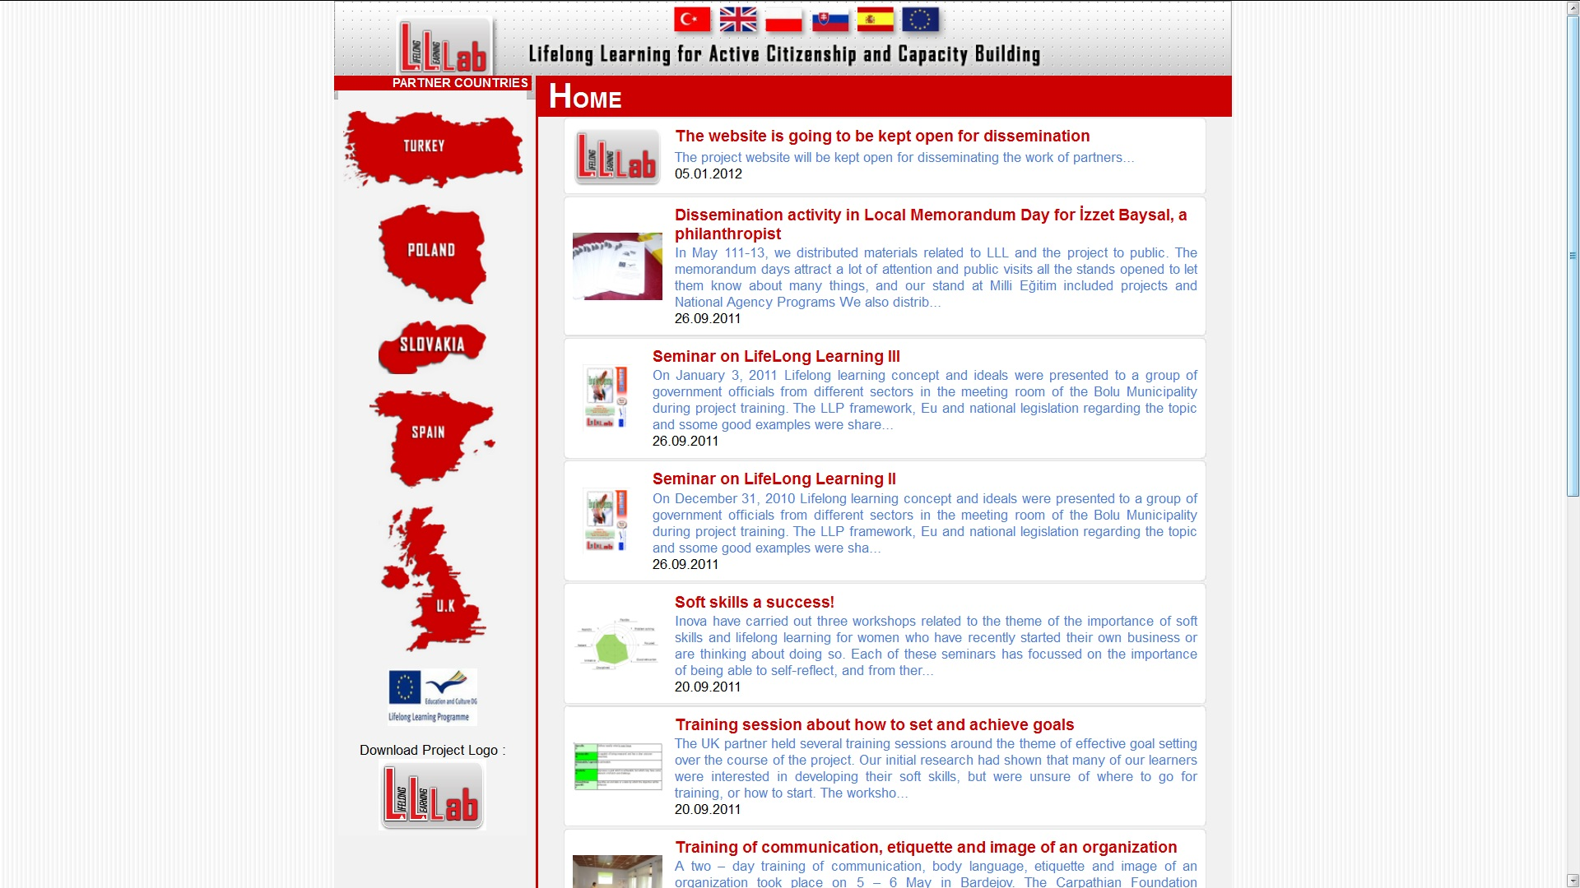
Figure 3. The LLLab project website

Learning Innovating Styles & Active Citizens – LISTEN [8], [9], [11], [12]
LISTEN Learning Partnership is focusing on teaching and learning methods. It provides teachers, trainers and learners with the opportunity to exchange experiences, practices and information regarding teaching and learning methods, to develop together new approaches which meet needs, to test and put into practice new pedagogical methods.
The main priorities are as following:
1. To increase motivation for learning and improving learning outcomes in adult education by introducing various teaching and learning methodologies.
2. To identify varied learning methods in teaching and how they are used to disseminate specific and academic content in any adult teaching situation.
3. To explore concretely defined teaching methods and compare it to the methods used by partners.
4. To disseminate the project and its results to other adult learning institutions, electronically and by open meetings.
5. Using the information gained in the project to reduce social vulnerability to include in particular; women, the over 50's refugees and those with limited education without reference to gender or nationality.
6. The partnership will include the learners, staff and volunteers from their organizations to fulfill the planed outcomes for the partnership and enable them to become active citizens.
7. Raise awareness about the choice of teaching method given our different cultural backgrounds.
8. Discuss and explore different teaching objectives.
This partnership has members from 7 European countries: Denmark (Laerdansk), Poland (PRO-MED sp. z o.o.), Wales (Learn with …), Romania (Grup Scolar Industrial Transporturi Cai), Germany (LOSOL), Italy (Galileo), Slovakia (Astra).
For each partner of the consortium the important task is adapting a favorite method or tool for their learners.
In case of PRO-MED sp. z o. o. up till now the following methods and tools were chosen for adaptation:
- Co-operative learning
- Evaluation method “Thinking hats”
- Approach to helping dyslexic students
- Story Cubes - a storytelling game
- DIALOGUE method for common thinking
For dissemination purpose the partners are using Tumblr (stylized as tumblr.). It is a microblogging platform and social networking website, owned and operated by Tumblr, Inc. The service allows users to post multimedia and other content to a short-form blog. Users can follow other users' blogs, as well as make their blogs private.
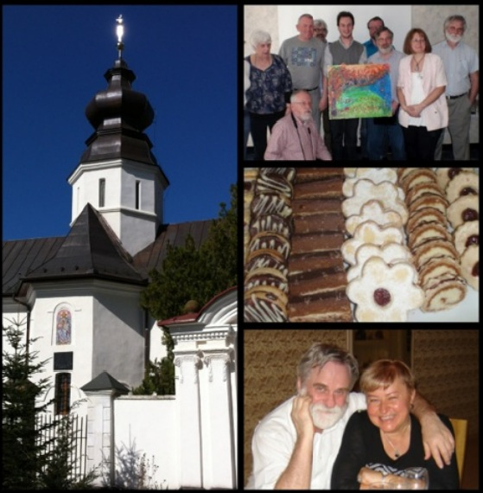
Figure 3. Polish adventures in Arad, Romania

Learning in Later Life – Europe – LLLE [6], [8], [9], [11], [12]
In particular the project LLLE aims to investigate some areas that may have great importance for learning activities in later life, and in which many older people are engaged, such as handcrafts, culture, arts and music. During the project the participating organisations will share their experiences and know how in this field, having insights into practice in other countries and collecting good practices.
The LLLE project enables older people and teachers from different countries, with different cultures and religions to meet and to share their experiences and knowledge. The approach to lifelong learning through practices like doing handicrafts, painting or singing for instance brings people together - overbearing cultural or language barriers. In this way the project improves exchanges between older people from different countries, with different cultures and religions, promote inter-generational activities, participation in the University of the Third Age, active citizenship and the spirit of European citizenship.
The LLLE partnership consists of organisations and older people working together in order to establish and expand a network for life long learning in senior age focused on organisations and older people themselves in the field of handicrafts, culture, arts and music.
The project Partnership consists of 5 members from 4 countries: France (ADREP, A.C.R.T.S.), Poland (PRO-MED sp. z o.o.), Spain (F.S.M.C.V.), Turkey (ICANO).
Each Partnership meeting should concentrate at the following main pillars: changing experiences, orientation for process, mobilities, learners involvement. More over the Partnership prepares and shares an international and national plan of project's activities, communication and co-operation plan, evaluation and dissemination plan, mobility plan.
For the project management purpose Moodle Learning Management System (LMS) is used
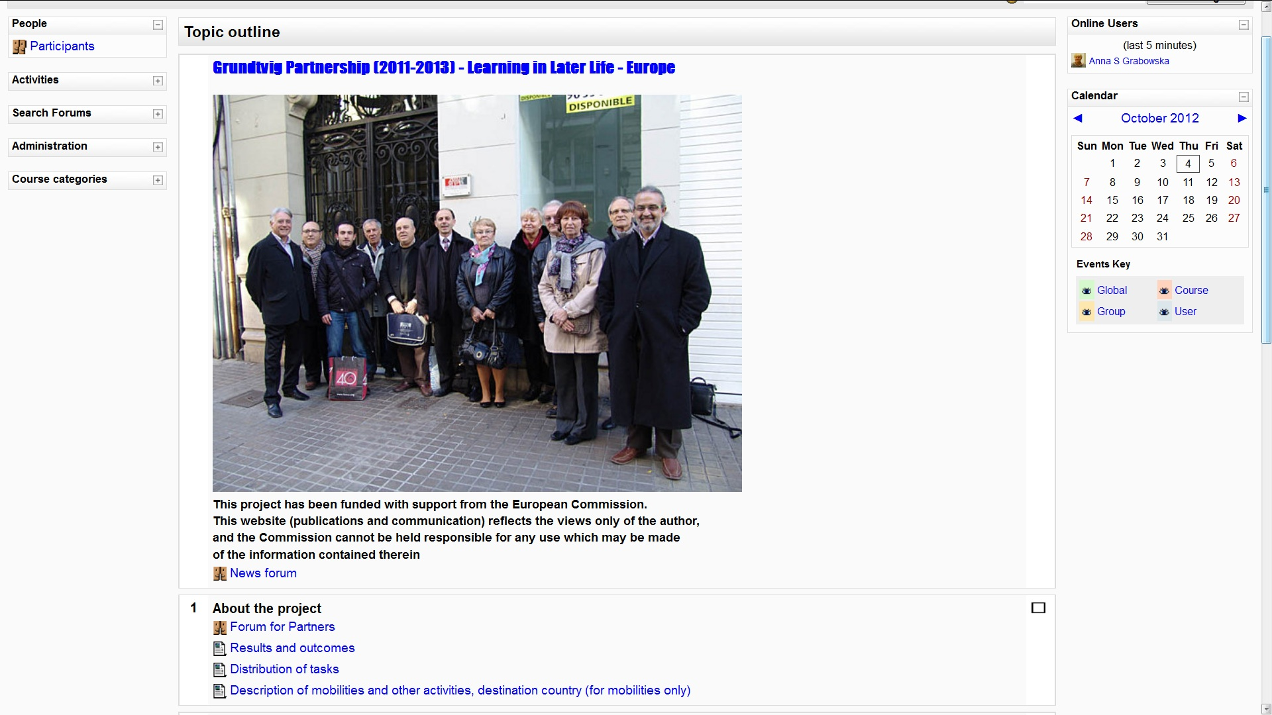
Figure 4. LLLE Project Management System in Moodle
In order to organize the project meeting in Gdansk in Poland a dedicated Forum was established (Learning in Later Life - Europe – meeting in Gdańsk, 16-21.10.2012). The details of a program for the participants were discussed and prepared together by PRO-MED sp. z o.o. staff and learners. As a part of activities a city game was proposed. The active participation in the game enables participants to be familiar with history and monuments of the city. The example page of the city game is shown in Fig. 5.
The special event for the participants of LLLE project meeting in Gdansk is planned in City Culture Institute (Fig. 6.). The her-story project „Metropolitanka” will be presented there. The project shows the often neglected role of women in history. Stories told from the perspective of women are focused on women connected with the Gdansk Shipyard. Through the project they want to conduct informal education, encourage cross-generation activities, increase the interest in the history of everydayness, maintain and support the memory of Gdansk Shipyard.

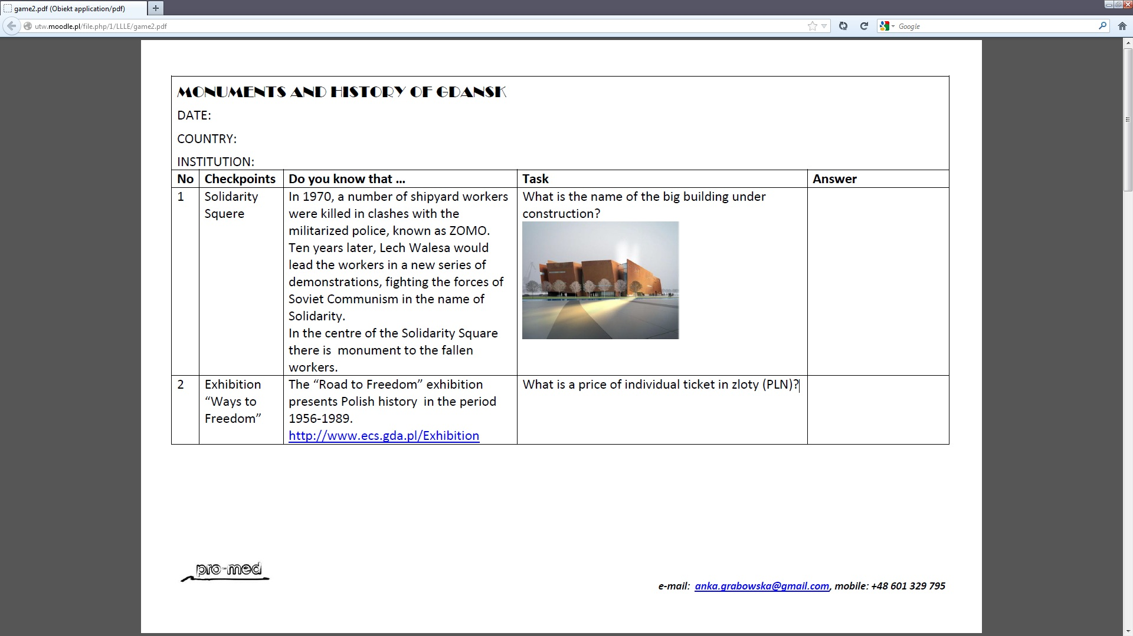
Figure 5. City game – example page
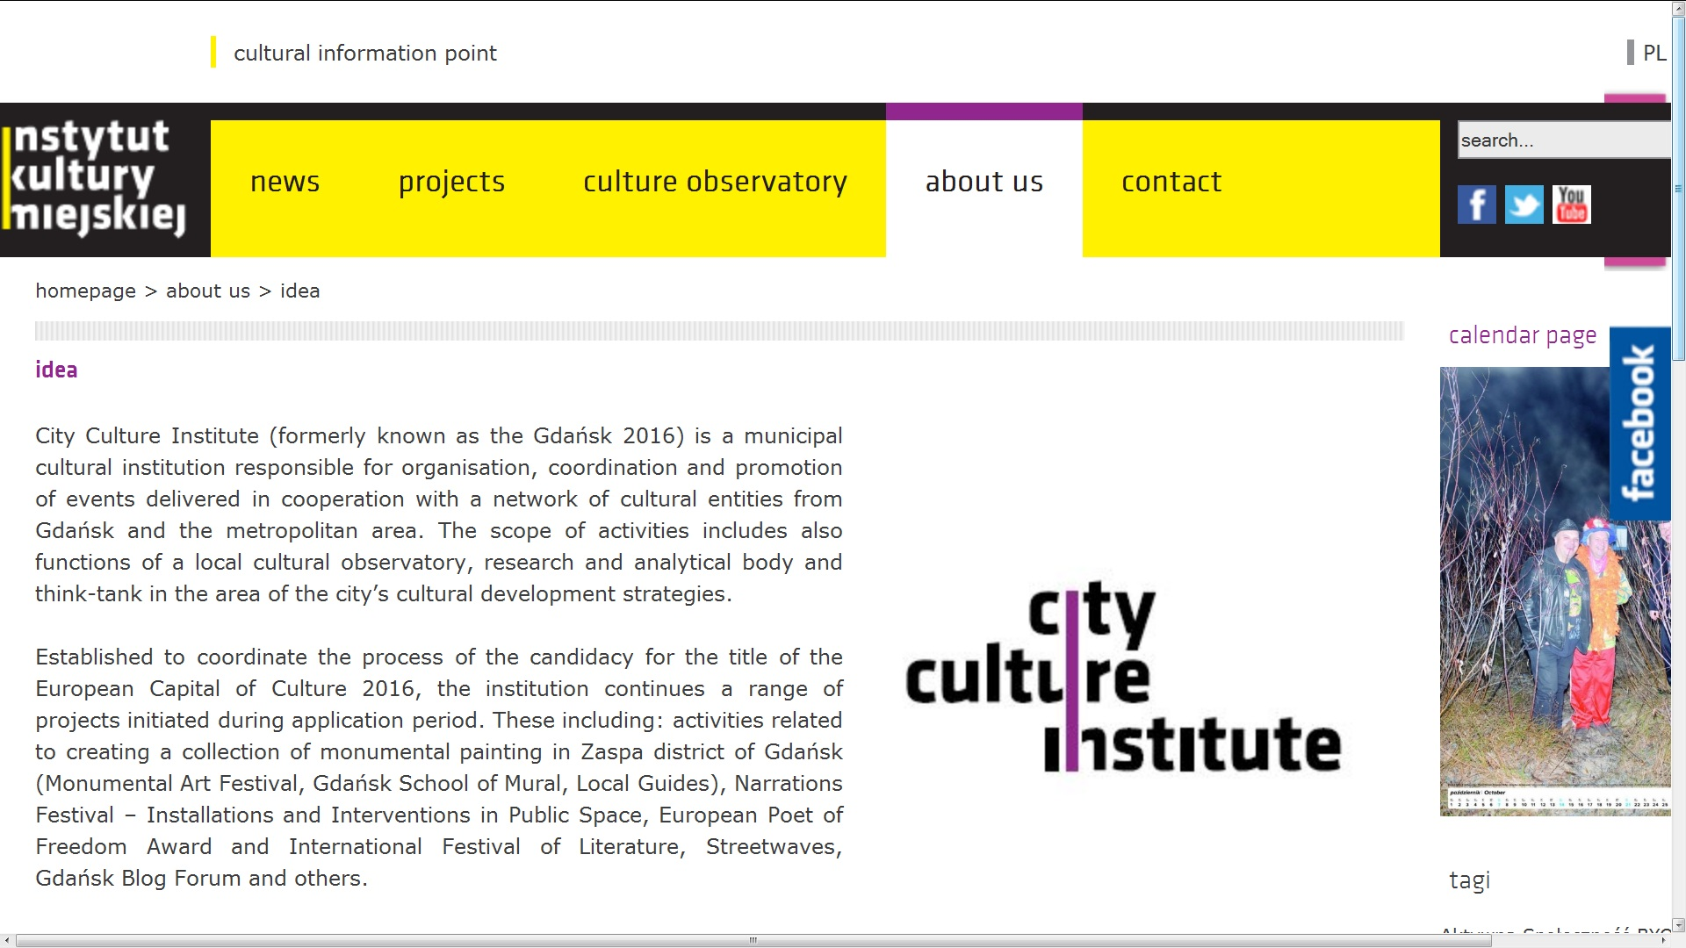
Figure 6. City Culture Institute website

V. ForAge - for the later-life learning – building on European experience [8], [9], [10]
The project ForAge is a European multilateral network which has the central aim of promoting and communicating the experiences of lifelong learning for older people to create higher standards of practice throughout Europe.
Since the first European Year of Older People and Intergenerational Solidarity in 1993 there have been many pan-European exchanges, projects, training events, seminars, programmes and networks concerned with learning in later life.
The numbers increased significantly with the Grundtvig programme proving impetus and funding for imaginative and innovative work across all of Europe. ForAge is designed to make wider and better use of all these rich experiences, building upon them, sharing information, analysing and assessing the value and impact on education and ageing policies, disseminating research evidence, and creating networks to do all this.
The ForAge partnership wishes to be the initial source of information for later life learning activities in Europe in order to:
- Allow for better dissemination of project reports;
- Encourage further use of tools and outputs to increase opportunities available to individuals;
- Create an archive and access point for EU and other initiatives concerned with disciplines that intersect with later-life learning;
- Provide a source of advice and information to emerging and current EU programmes and access to sources of research evidence of the value of later life learning;
- Provide information on relevant focus years and days; seminars and training events;
- Provide regular information on relevant new policy directions;
- Negotiate for standardised methods of data collection and dissemination to assist comparisons, analyses and understanding;
- Better frame and stimulate debates across bureaucracies, disciplines and silos;
- Be an agency where debate stimulates change;
The ForAge partnership main goals are following:
- To create an interactive portal for each EU country to feed data about later-life learning – practice, policy, research, success and failure into an ongoing, sustainable, interactive and accessible database for wider use;
- To promote the use of data for research, analysis, sectoral searching, project building and partner searching;
- To document, evaluate and analyse projects at a European level and promote new ways to utilise results;
- To promote collaboration and participation across disciplines;
- To create links and methods of cross-communication with other relevant EU networks, projects, programmes and potential partners;
- To give access to any databases of (good) practice in a range of learning areas around later life learning; education and ageing and training of educators in these fields;
- To offer an online forum for ‘live’ participation in debates/discussions around particular topics;
- To enhance the usage and value of data held on EVE, ADAM and EST databases;
- To encourage debate through our three pan European seminars and ‘virtual’ conferences, discussion groups, forums and consultations. These will be reported in our nine newsletter and three annual progress reports
- To produce reports to disseminate to key stakeholders about our work and findings
More over the ForAge partnership wants:
- To connect later-life learning ideas, projects, policy, research and voices of older people, and thereby promote an integrated and coherent approach in future policy and practice;
- To develop dialogue with key national and European politicians and decision makers concerning emerging and key themes and issues in later life learning;
- To signpost to a lexicon of terms used across Europe and in disciplines relevant to later-life learning.
ForAge will increase the membership of the network by:
- Adopting dissemination strategies to publicise the Forage identity and aims;
- Developing the resource in all major languages used in the EU;
- Embedding publication strategies to promote the network from the initial stages of development;
- Aspiring to create a free-standing association for later life learning in Europe.
The ForAge partnership consists of the following organisations:
- University of Leicester, Leicester, UK
- bia-net, Graz, Austria
- Cyprus Adult Education Association, Cyprus
- Finnish Adult Education Association, Helsinki, Finland
- 50plus Hellas, Athens, Greece
- Trebag Property & Management Ltd, Budapest, Hungary
- Lunaria, Rome, Italy
- The Elephant Learning in Diversity BV, Nederland
- PRO-MED sp. z o. o., Gdansk, Poland
- AidLearn, Lisbon, Portugal
- IMBD, Brno, Czech Republic
- EUROED Association, Bucharest, Romania
- Association for Education & Ageing – AEA, UK
- Comenius University, Bratislava, Slovakia
- MERIG, Graz, Austria
- The Slovenian Third Age University, Ljubljana, Slovenia
- Cordoba University, Cordoba, Spain
- Age Action Ireland, Dublin, Ireland
Current Associate Partners:
- Workers Education Association, Belfast, Northern Ireland
- The Age Platform Europe, Brussels Belgium
- BAGSO, Bonn, Germany
The project portal prototype is located at http://www.foragenetwork.eu/ and offers the following functionalities: Policy issues, Research, Conferences, Publications, Links, Newsletters. The databases will be soon filled in by all partners.
The most important feature is enabling quick and efficient search engine which will support searching inside and beyond ForAge portal.
The ForAge project is co-ordinated by the University of Leicester’s Institute of Lifelong Learning, which has established an international reputation for work in the field of older people and lifelong learning, and is in partnership with the UK’s Association for Education and Ageing. The Leicester team is led by Jim Soulsby as ForAge Network Facilitator.
In the second Newsletter Jim Soulsby was asked by the author of this article the question “What was the genesis of ForAge?” and the answer was following::
“I have worked in this area for over 25 years and in that time I have observed so many wonderful, inventive and fascinating learning programmes involving older people. It is impossible to keep them all in your head! I believed that other people should know about the work being undertaken, how it happened, what were the difficulties and successes, and how older people were involved in making it all happen. Obviously over the years things repeated themselves and I always thought it a shame that there was no way of gathering together all these experiences so we could use them to help with future developments, not only in anticipating or overcoming difficulties, but in utilising all that expertise to assist. I have always believed that we would be more successful and able to sustain what we do if we could collaborate better with others.
Whilst I was at the National Institute for Adult Continuing Education (NIACE) in England working on “Older and Bolder” I tried to develop a database of (good) practice to better record all that I and my colleagues observed or had brought to our attention. I attempted to launch this database across the membership of the European Age Platform. My participation in numerous European programmes, conferences and exchanges had brought to my attention lots of educational activities right across Europe. In recent years, through seeking the advice of all those European partners and collaborating with others in a Grundtvig training programme, I came to realise that there was an opportunity to try to bring together all of this magnificent work over recent years. Thus, ForAge was born.”

VI. Summary
What are the author future expectations as far as the valorisation of European projects results is concerned [1]?
For ongoing Grundtvig projects Moodle LMS has been used (Fig. 7.). It should be underline that the first implementation of Moodle at Gdansk University of Technology took place nine years ago in 2003.
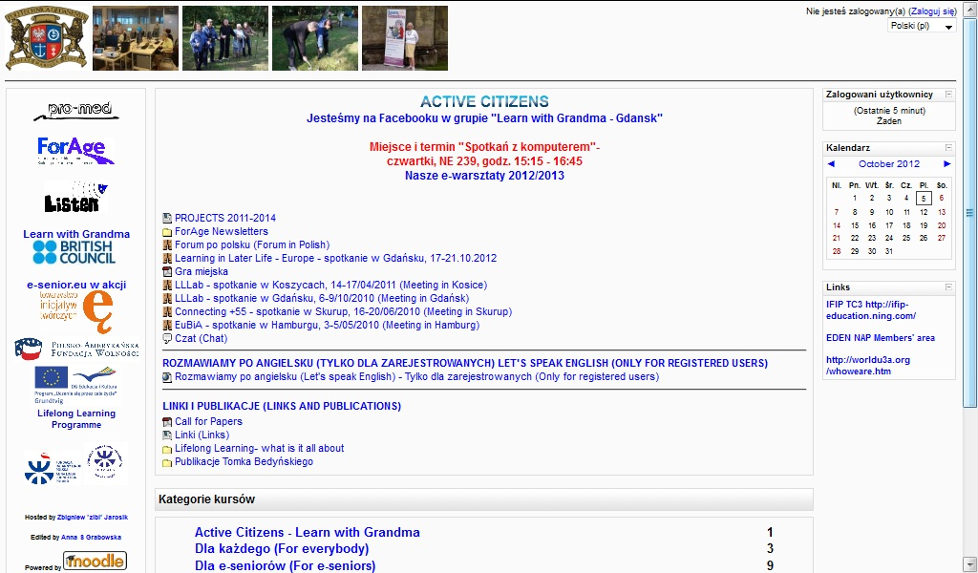
Figure 7. Moodle for Gdansk University of Technology seniors
The first steps have been done in co-operation with Gdansk University of Technology and Academic Computer Centre (CI TASK) in Gdansk http://www.task.gda.pl/. The process of building Open Educational Resources for the Universities of Third Age together with CI TASK (Fig. 8.) has just started.
The example materials can be found at the address http://utwpg.gda.pl/.
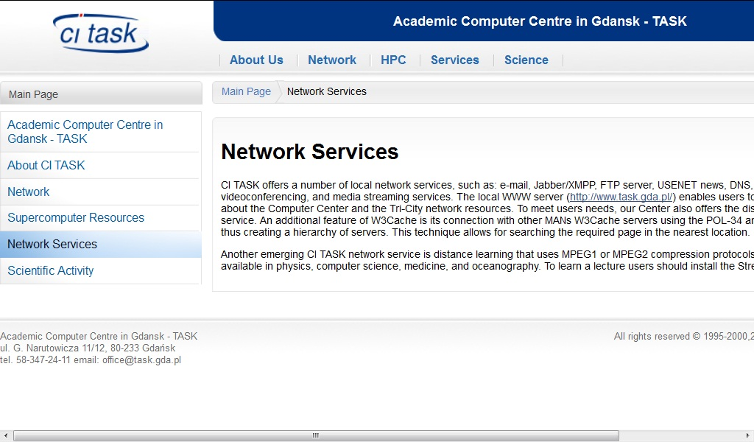
Figure 8. CITASK Network Services
The author offers a magazine online “e-senior”. The idea of establishing “e-senior” magazine was born at EDEN 2008 Conference in Lisbon during the workshop “Collaborative Learning and User Generated Content Creation With The Multilingual MagazineFactory - An Example of a Social Software, Dynamic Content Creation and Mashup All Wraped Up in a Single Tool” presented by Christian Komonen, Executive Producer of MagazineFactory.
Up till now several articles about international projects have been published there (Fig. 9.).
For dissemination and valorization purposes in August 2012 a multilingual article, which can be created by the project partners together, was proposed (Fig. 10.)

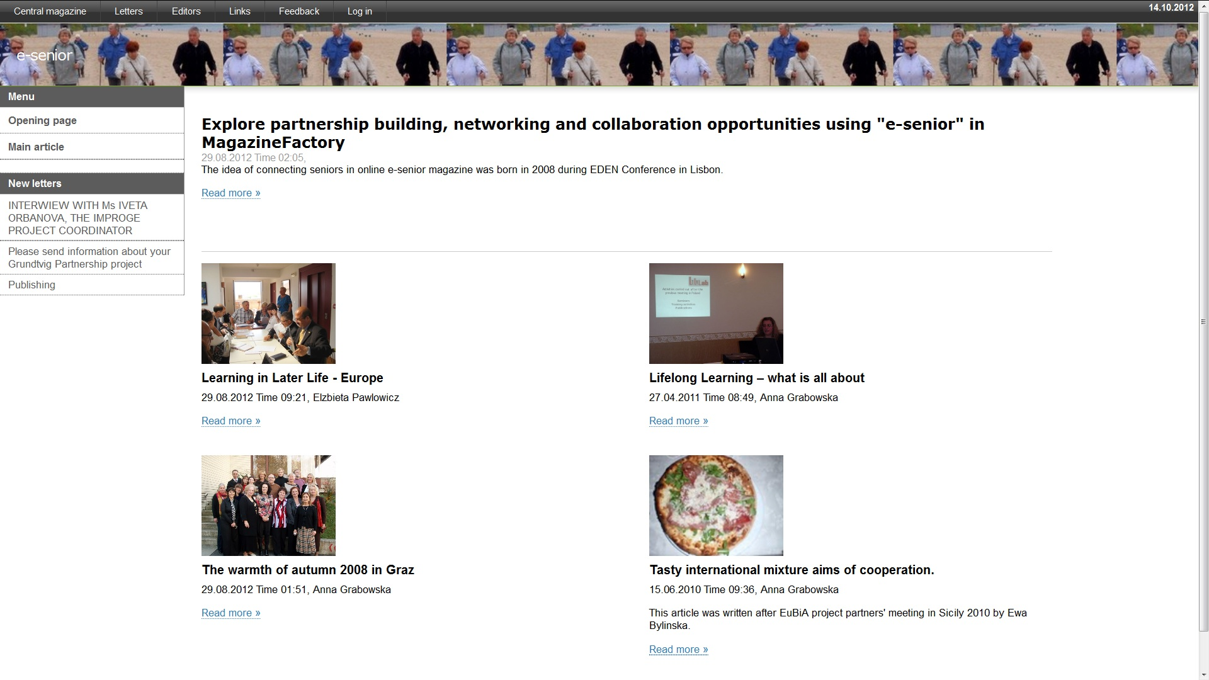
Figure 9. Magazine e-senior

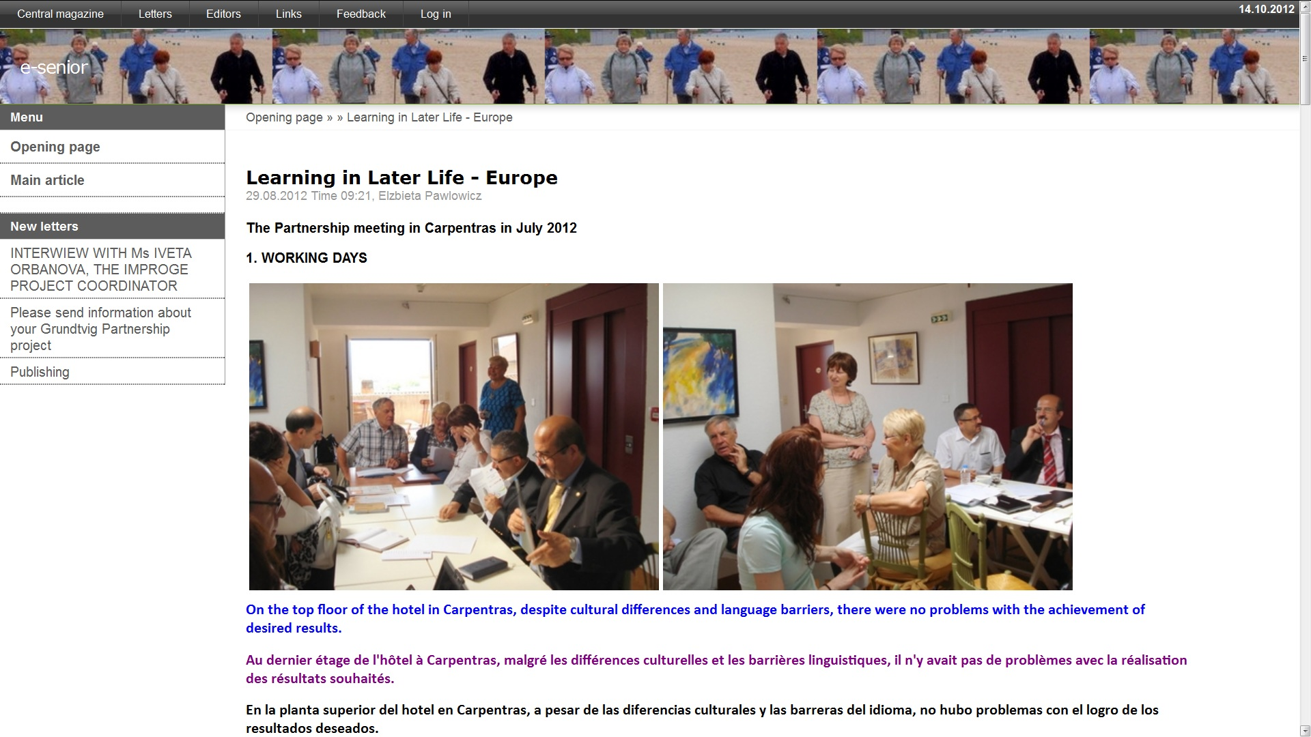
Figure 10. Learning in Later Life Europe” in e-senior magazine
More over PRO-MED sp. z o.o. learners and instructors those who are taking part in European projects can also communicate using Facebook. The closed group “Learn with Grandma – Gdansk” was started in March 2012. Up till the group has got 50 members from Poland, Turkey and UK.
Having a broad range offer of internet based solutions as open source software and open source content we really can discover learning in later life in Europe.

Acknowledgment
The projects LLLab, LISTEN, LLLE, ForAge have been funded with support from the European Commission.
This publication reflects the views only of the authors and the Commission cannot be held responsible for any use which may be made of the information contained therein.

References
- A. Grabowska, Valorisation of European Projects Results, in Book of Abstracts EDEN Annual Conference 2007, New Learning 2.0?, Neapol 2007.
- A. Grabowska, “Grundtvig Partnership Case Study 2009-2011 LifeLong Learning for Active Citizenship and Capacity Building LLLab,” in Competencies in the Knowledge Society, International Federation for Information Processing, Berlin 2010 pp. 136–143.
- A. Grabowska, “From “e-Senior “ Magazine and “e-Senior in Action” to “Learn with Grandma”, in Book of Abstracts EDEN Annual Conference 2011, Learning and Sustainability, Dublin 2011.
- European Parliament resolution, “Education, training and Europe 2020,” Strasbourg, September 2012.
- European Association for the Education of Adults, “GRUNDTVIG AWARD 2012 Innovative Approaches in Adult Education and Learning - Key competences for social inclusion”, Lifelong Learning Programme, 2012, pp.32–34.
- http://magazinefactory.edu.fi/magazines/e_senior/
- http://www.lilelab.com/
- http://utw.moodle.pl/
- http://blanka.moodle.pl/
- http://www.foragenetwork.eu/
- http://www.facebook.com/groups/221342244591943/
- http://utwpg.gda.pl/

