No | Checkpoints | Do you know that … | A photo from wikipedia | Add photos from  Anka’s album
1 | Sveta Nedelya | Sveta Nedelya is a medieval church that has suffered destruction through the ages and has been reconstructed many times. It was designed by the famous Bulgarian architectural team Vasilyov-Tsolov. | 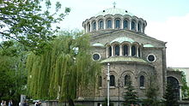
2. | The Church of Saint Petka | The church was first mentioned in the 16th century and was constructed at the place of a former Roman religious building. It is today a monument of culture known for its mural paintings from the 14th, 15th, 17th and 19th century depicting biblical scenes. | 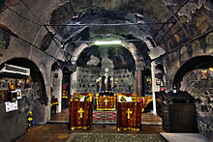
3. | The Central Mineral Baths | The Central Mineral Baths is a landmark in the centre of Sofia, a city known for the mineral springs in the area. It was built in the early 20th century near the former Turkish bath (then destroyed) and was used as the city's public baths until 1986. | 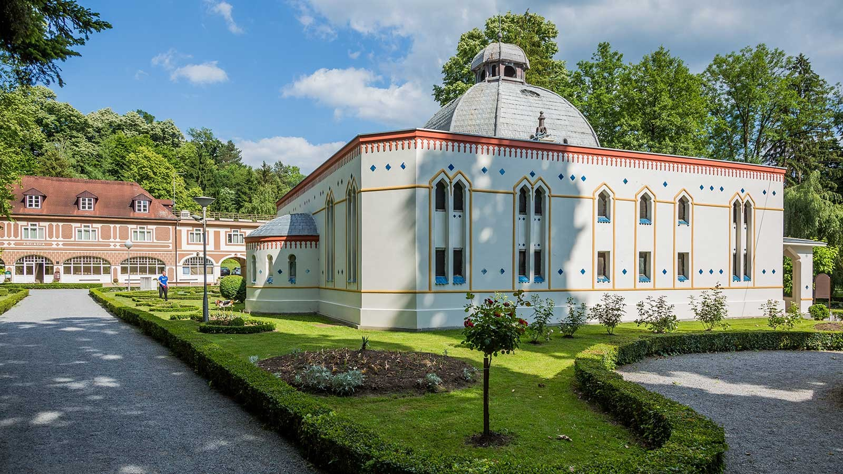
4. | Sofia Synagogue | The Sofia Synagogue is the third largest synagogue in Europe (after Budapest and Amsterdam) and was built by Friedrich Grünanger. | 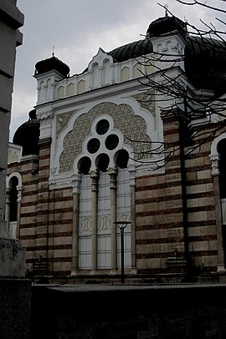
5. | Alexander Nevsky Cathedral | Saint council Alexander Nevsky - the Orthodox Cathedral in Sofia, the main temple of the autocephalous patriarch of the Bulgarian Orthodox Church. | 