No | Checkpoints | Do you know that … | Photos  Answer a question | Your tasks:  Answer a question  Add your photo
1 | Scandic hotel | The name of the hotel has changed:  Hotel Monopol (1949-1996)  Holiday Inn (1998-2008)  Hotel Scandic (2009 - | 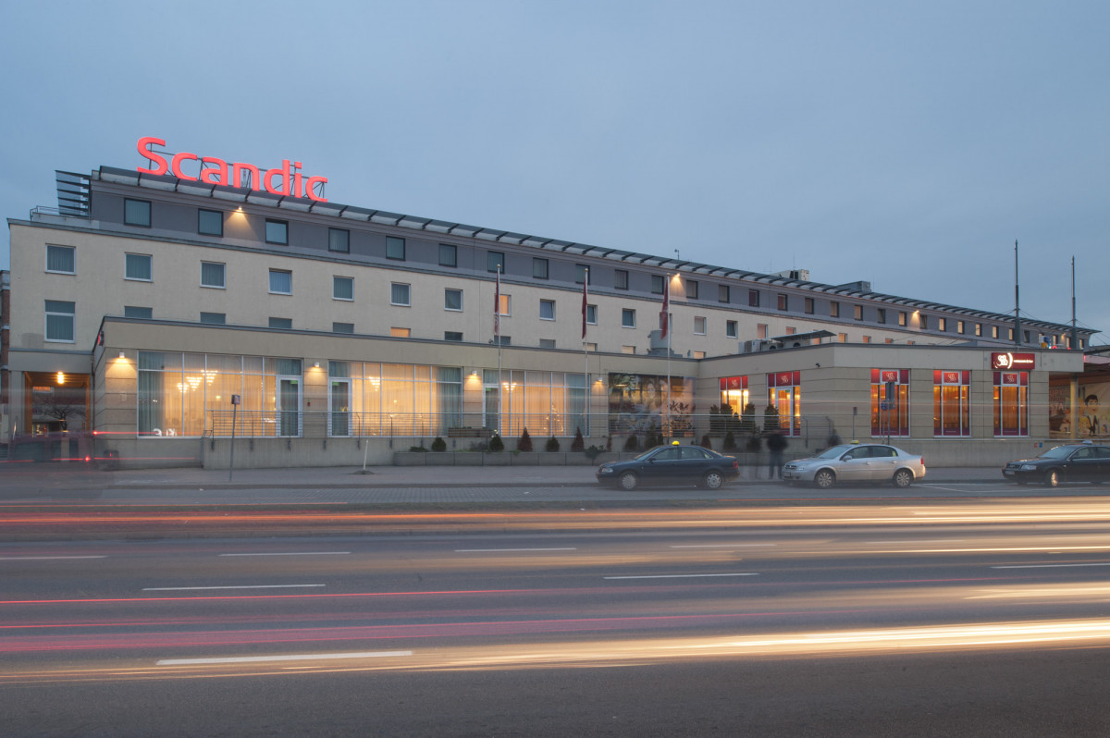 | How many stars has Scandic hotel? 4 stars
2. | Old Town Hall | The historic town hall from the end of the 16th century, one of the most valuable monuments in Gdańsk. For centuries at this place was focused the political, economic and scientific town's life; formal celebrations and evening's balls and banquets. | 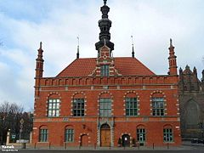 | What famous astronomer used to work in the Old Town Hall ? Jan Heweliusz
3. | Johannes Hevelius Monument | Jan Heweliusz (1611-1687) - the astronomer, he gained a reputation as "the founder of lunar topography". He described ten new constellations, seven of which are still used by astronomers.  He compiled an atlas of the Moon (Selenographia, published 1647). A few of his names for lunar mountains (e.g., the Alps) are still in use, and a lunar crater is named for him. Hevelius also made a catalog of 1,564 stars, the most comprehensive of its time. | 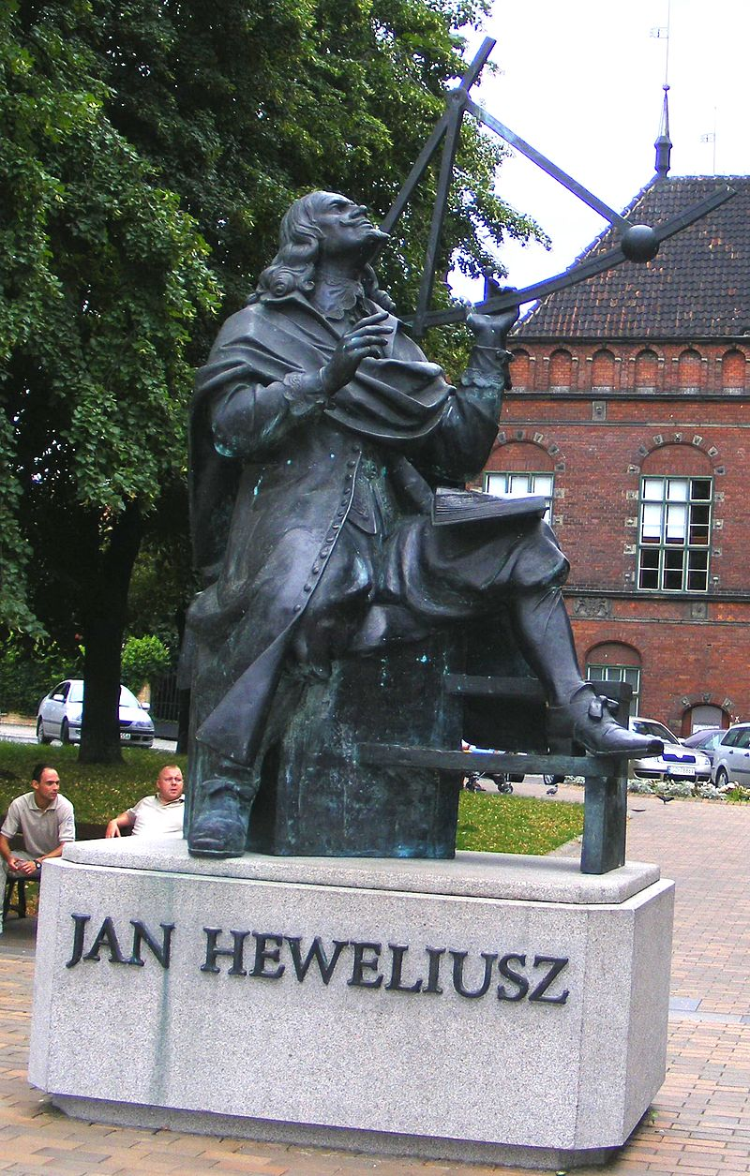 | What is Heweliusz looking at? He looks at the map of sky drawn on the building's wall.

4. | Market Hall | Market Hall was built at the end of the 19th century on Dominikański Square, which was always full of life and trade. Inside it, the space was divided into three commercial routes by 22 cast-iron pillars, in which were used constructional solutions typical of viaducts - this allowed, among others, to increase their resistance to severe frosts. Four gates led to the center of the building (until today nothing has changed). | 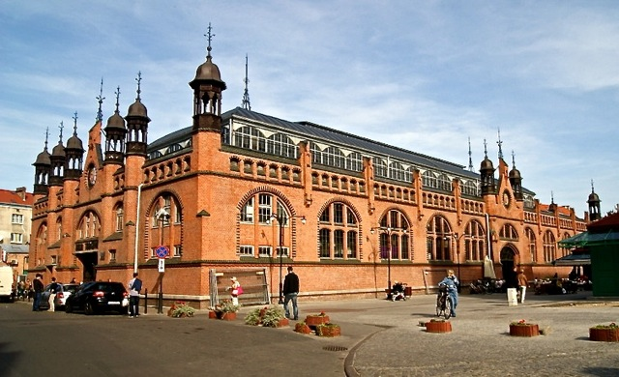 | What is the sign above the gate to the Market Hall?  The Gdańsk coat of arms is located above each of the four gates.
5. | Grand Arsenal | Standing at the end of Piwna Street, this elegant building shows Flemish Renaissance influences. | 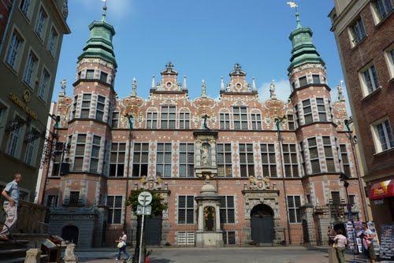 | When was it build?  1602-1605
6. | Golden Gate | The gate is a mix of Flemish and Italian styles. Since its reconstruction and renovation it has served as a symbol of the city as a whole. There are several figures on a top of the gate. Below the figures you can read the Latin Maxim: ‘Small states grow in harmony, large states fall in discord’.  Walk through the gate, you can see an exceptional view of Dluga street and the Old Town Hall! | 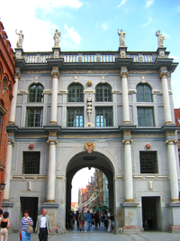 | How many figures are standing proudly on top of the gate? 8
7. | Main Town Hall | The Town Hall spire, with a golden replica of King Zygmunt August on its pinnacle, dominates ul. Długa's skyline. Built in the late 14th century as the seat of city authorities, the Town Hall hosted many Polish kings. It was almost completely destroyed during WWII but rebuilt with extraordinary care. The tower has a carillon composed of 37 bells, playing melody on full hours. | 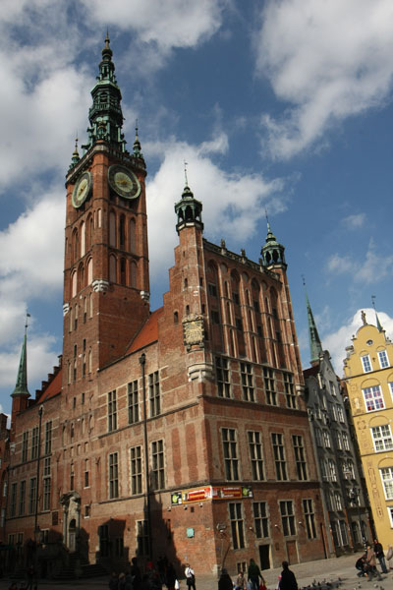 | In what style is built the Main Town Hall?  Main Town Hall is built in the Gothic-Renaissance style.
8. | Neptun’s Fontain | Neptune Fountain was designed by Abraham van den Blocke. The basic idea behind the water sources is the trident of the god of the seas and oceans, with a sea horse at his foot as well as the corner of the pedestal | 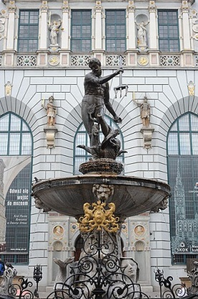 | In Roman mythology Neptun is god of seas, oceans.  Give the name of the god of sea in Greek mythology. Posejdon
9. | Green Gate | The Green Gate was clearly inspired by the Antwerp City Hall. It was built 1568-71 as the formal residence of Poland's monarchs. It is a masterpiece by Regnier, an Amsterdam architect, and reflects Flemish architectural influence in Gdańsk. Hans Kramer from Dresden was responsible for the construction plans. | 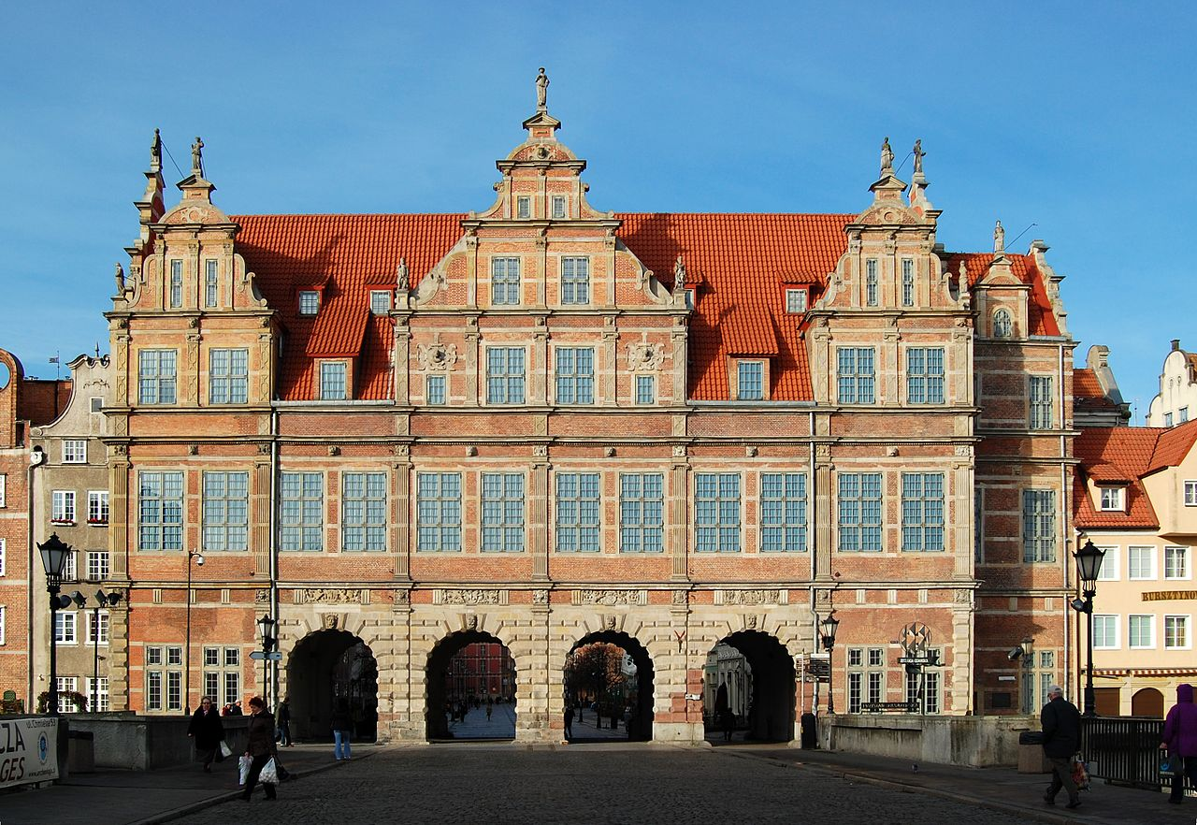 | Where is situated the Green Gate?  Between Long Market and the River Motława.
10. | The Crane | The oldest documented mention of Zuraw as a wooden port crane was in 1367. What you see today, however, was reconstructed in the middle of the 15th century after a devastating fire devoured the original structure. | 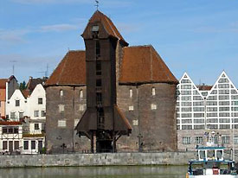 | What bird is on the top of the building?  Crane
11. | Soldek the vessel | “Sołdek” is the first ocean-going vessel put into operation in the history of the Polish shipyard industry. You can visit the National Maritime Museum https://en.nmm.pl/ | 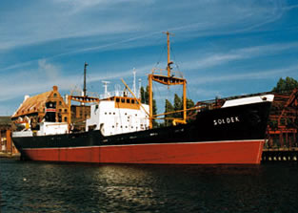 | How old is the vessel?  In 2018 – 70 years old
12. | Mariacka Street | Although the street was a pile of rubble after the Second World War, it has since been faithfully reconstructed in its original Gothic style. | 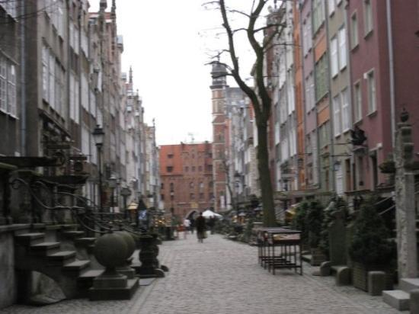 | Are there any amber shops and silver stores ?  Yes
13. | St. Mary’s Church | The biggest brick wall church in the world and one of the biggest churches in general.  The church was severely damaged in World War II, during the storming of Danzig city by the Red Army in March 1945. | 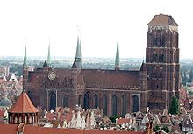 | It can hold up to 25,000 people – true or false?  True

